Depo-Provera
LEAD INFORMATION
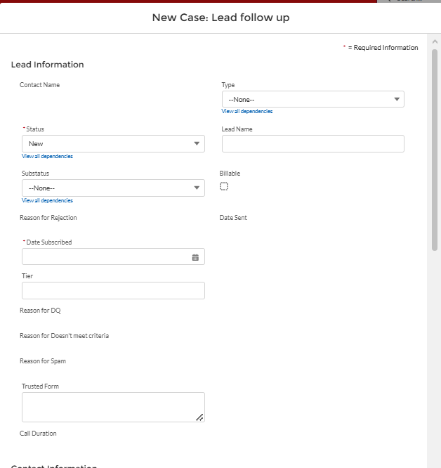

TYPE (Drop Down Options)
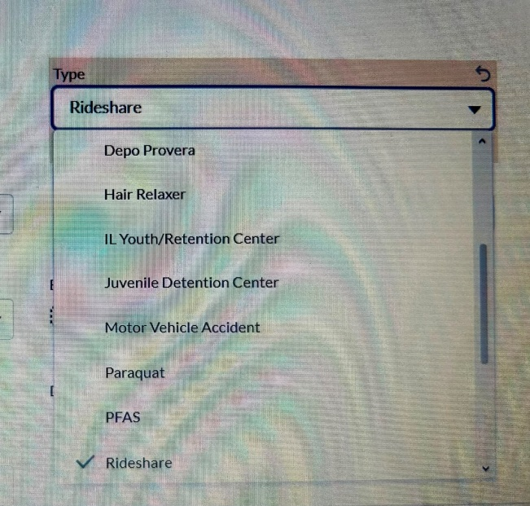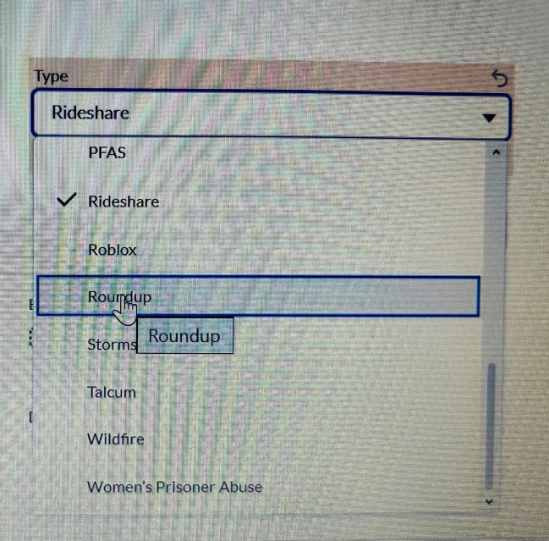
Status (Drop Down Option)
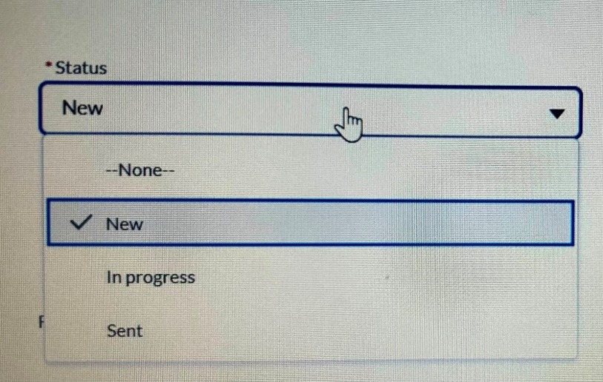
Substatus (Drown Down Option)
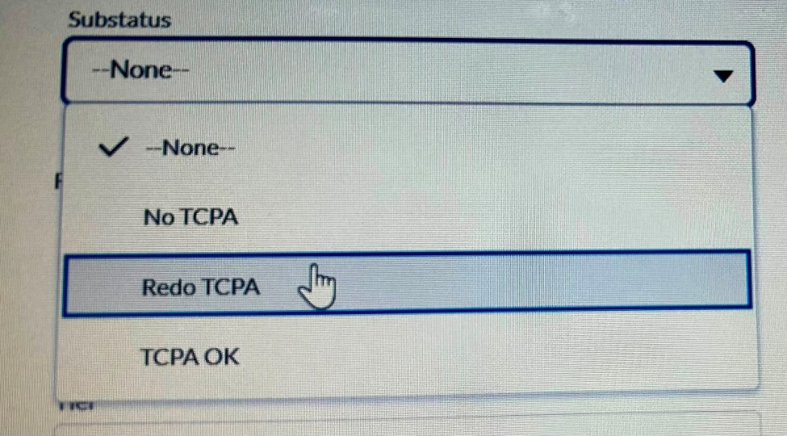

Date Subscribed
Format – Month/Date/Year (ex.12/31/2026) (SHOULD BE USED FOR ALL DATES)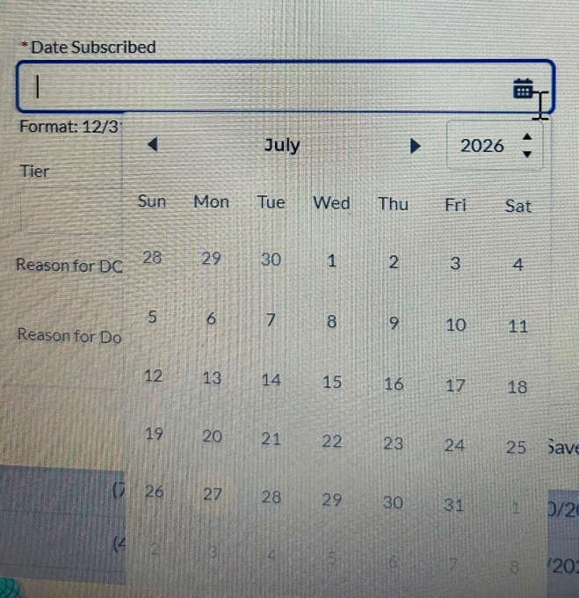

Contact Information
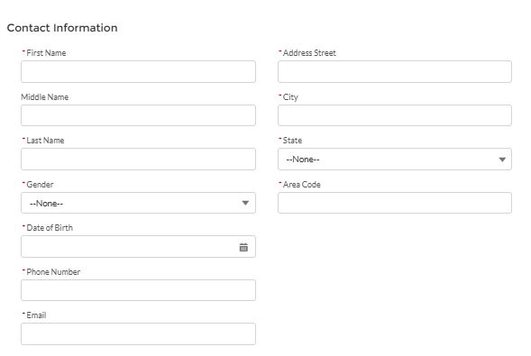
Gender (Drop Down Option)
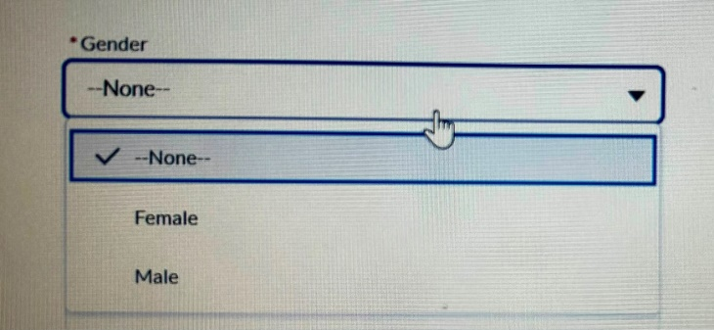

State (Drop Down Option)
(ALL US 50 STATES ABBREVATION SHOULD BE ADDED)
• AL
• AK
• AZ
• AR
• CA
• CO
• CT
• DE
• FL
• GA
• HI
• ID
• IL
• IN
• IA
• KS
• KY
• LA
• ME
• MD
• MA
• MI
• MN
• MS
• MO
• MT
• NE
• NV
• NH
• NJ
• NM
• NY
• NC
• ND
• OH
• OK
• OR
• PA
• RI
• SC
• SD
• TN
• TX
• UT
• VT
• VA
• WA
• WV
• WI
• WY
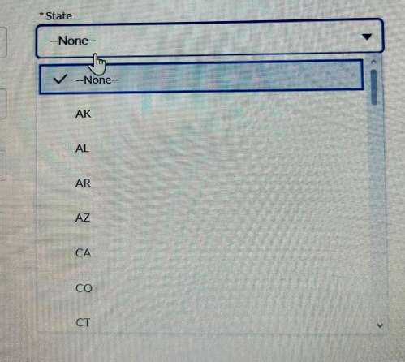

POA
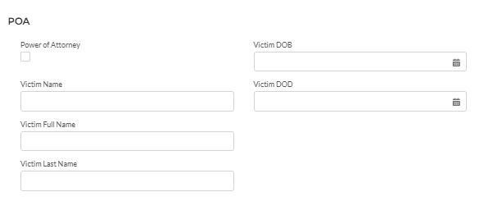
DIAGNOSIS INFORMATION
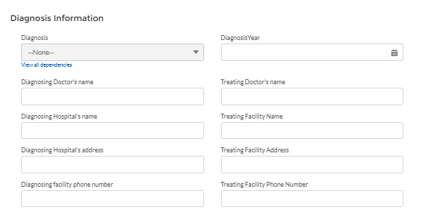
Q) Diagnosis
Meningioma
Other
OTHER CASE INFORMATION

Other Case Information

How long did you used the Depo-Provera injections?
(For Answer Pls add blank box)
How often did you receive Depo-Provera Injections?
For Answer (pls add Blank Box)
Total Depo-Provera Injections received?
For Answer (pls add Blank Box)
When did you Started receiving :
For Answer (Date Selection)
When did you Stopped receiving:
For Answer (Date Selection)
Where was the Injection Administered
For Answer (pls add Blank Box)
What Location/Address was Injection Administered
For Answer (pls add Blank Box)
Reason of Stopped Using Depo-Provera/ Symptoms Before Diagnosis:-
For Answer (pls add Blank Box)

Symptoms Started Date :- For Answer (Date Selection)

How did they Confirmed your Diagnosis / Test before Diagnosis :-

Date of Test :- For Answer (Date Selection)

Treatment :-

Treatment Date :- For Answer (Date Selection)
Have you suffered any long-term complications, like infertility
Yes
No
HIV/AIDS?
Yes
No
Did you have any legal representation with any law firm regarding this claim?
Yes
No

Conviction Felony/Crime?
YES
NO

Do you have Medical Records?
Yes
No

